Quick Acoustic Analysis

of

Volley 5, 3rd Burst

Front Row – Center Stage

author
date
version

Table of Contents
Introduction 3
Background Material 3
Video Source 4
Listen 5
Waveform (plot of signal amplitude v. time) 5
Spectrogram – Db2 (a measure of energy) 6
Spectrogram – Log Frequency v Time 7
Spectral Contrast Color Plot 8
Muzzle Blast Data 9
Shock Wave Data 10
Lag Calculations 11
Summary 12
Compare to Other Video/Audio 12
Other Observations 12
Theory Would Predict 12

Introduction

This paper presents a simple acoustical analysis of one part of a volley of gunshots. Purposely very little math or technical jargon is used, just enough to present the observations and introduce the reader to a portion of the tools and techniques used in forensic gunshot analysis. Links are provided to background material for the inquisitive.

Background Material

As explained in many texts, a weapon that fires a supersonic projectile will produce several sounds, the most dominant of which are (1) muzzle blast (2) shock wave from supersonic projectile, reflections (ground or otherwise) from (1) and (2), as well as possible sounds of the projectile hitting an object.

Video Source

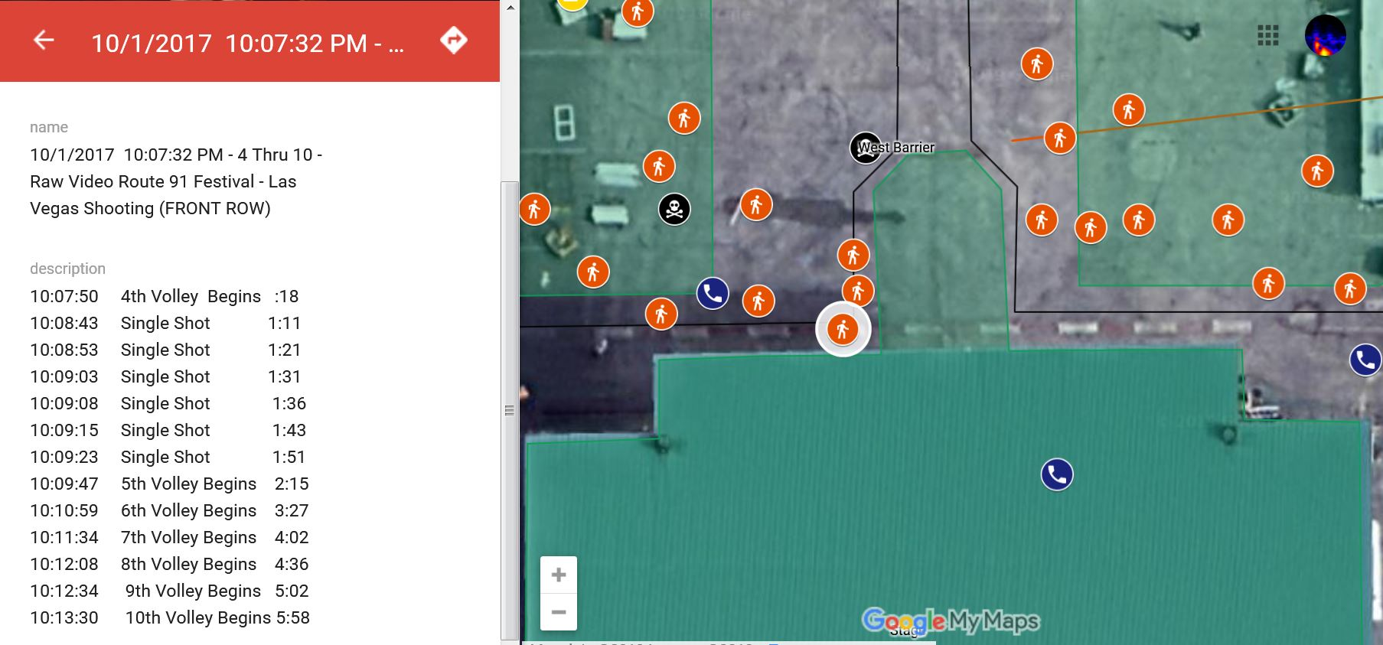

Very near front of stage in middle, hidden by lattice.

https://youtu.be/l-IEme0aGMA

A 1.37 second segment beginning at 2:23.05. This is the 3rd burst of volley 5.

Listen

Hear 11 or 12 shots, the first ones “snap” like sound, the last ones more of a “boomish” sound. Screaming in the background.

Waveform (plot of signal amplitude v. time)

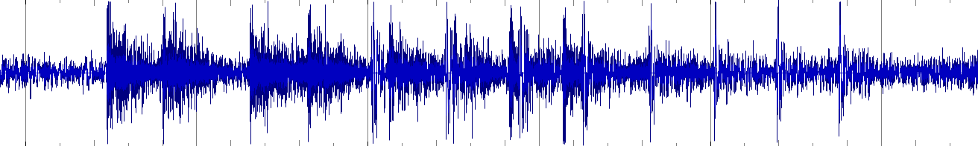

Observations:
- possible 12 – 16 total pulses.
- possible 8 pulses starting from end of segment that are fairly narrow in scope.
- 8 wide/noisy pulses at start of segment
- 3 or 4 of the narrow pulses overlap with earlier “wider” pulses
- most of all pulses are larger in amplitude than background sounds.
- Spacing between narrow pulses more regular than spacing between wider pulses.

Spectrogram – Db2 (a measure of energy)

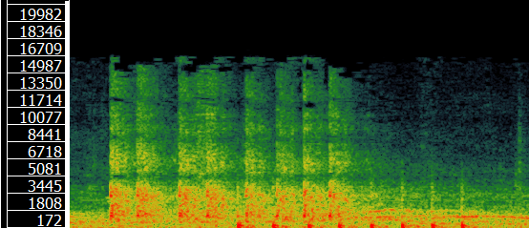

Observations:
- at least 12 distinct pulses
- first 8 pulses are broadband and have their power spread over a large range of frequencies.
- First 8 pulses are spread (smeared) over time.
- Last 4 pulses much narrower frequency band
- Last 4 pulses more confined over time
- close examination (large magnification) suggest 4 more pules burried within the first 8 that are similar to last 4 bringing total to possible 16 total pulses.

Spectrogram – Log Frequency v Time

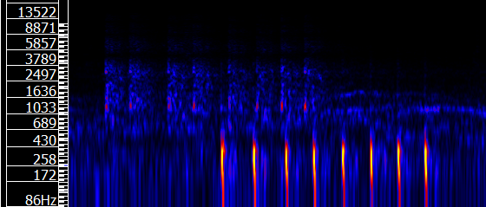

Observations

- 8 pulses in the upper band, 8 pulses in the lower band. Upper band of lower “intensity”. Upper band smeared over time. Indirect path for upper band.
- Muzzle centered between 500-150 hz.
- Sonic centered between 4,200 – 600 hz

Spectral Contrast Color Plot

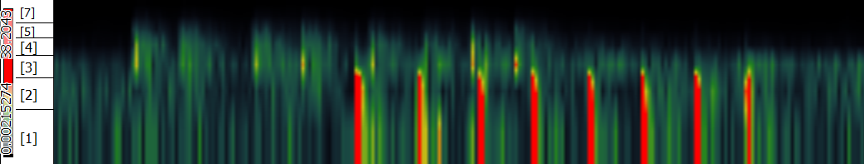

Observations:

- two distinct frequency groupings
- 8 strong pulses in the band 2/1,
- 8 weaker pulses in bands ¾.
- Put all these in terms of frequency contrast

Muzzle Blast Data

Plus or minus 2 m.s.
Raw data (all digits) taken directly from an “instants” layer of the above spectrograms created in Sonic Visualiser.

Vid. Time | Delta | R.P.M. | Variance
2:23.505215
2:23.612698 | 0.107483
2:23.719954 | 0.107256
2:23.812925 | 0.092971
2:23.909297 | 0.096372
2:24.004535 | 0.095238
2:24.095011 | 0.090476
2:24.186621 | 0.091610
 | 0.0973 | 616 r.p.m.

Shock Wave Data

Lag Calculations

Summary

Compare to Other Video/Audio

Other Observations

Theory Would Predict

